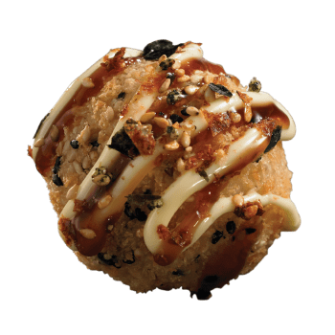  Teriyaki Bomb:  - Ext. Japanese Mayo  - Teriyaki Sauce  - Sesame  - Japanese Spices  - Int. Crab  - Shrimp  - Mozzarella  - Spicy Light Mayo  - Japanese Mayo  - Teriyaki Sauce | 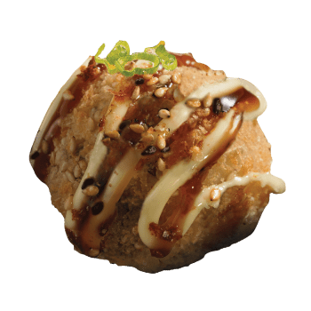  Veggie Bomb: Not Vegan!  - Ext. Japanese Mayo  - Teriyaki Sauce  - Sesame  - Green Onion  - Int. Torched Red Bell Pepper  - Carrot  - Mozzarella  - Spicy Light Mayo | 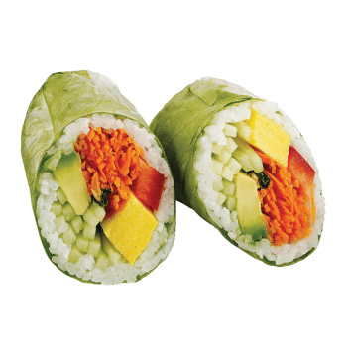  Spring Maki Veggie:  - Tamago  - Lettuce  - Carrot  - Avocado  - Red Pepper  - Cucumber  - Rice  - Sesame  - Rice Paper
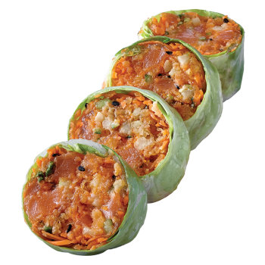  Salmon Tartare Maki:  - Salmon  - Tempura  - Lettuce  - Cucumber  - Carrot  - Green Onion  - Spicy Light Mayo  - Spicy Sauce  - Orange Masago  - Sesame  - Rice Paper | 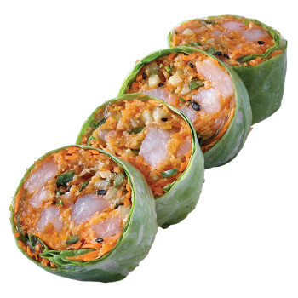  Shrimp Tartare Maki:  - Shrimp  - Tempura  - Lettuce  - Cucumber  - Carrot  - Green Onion  - Spicy Light Mayo  - Spicy Sauce  - Orange Masago  - Sesame  - Rice Paper | Veggie Tartare Maki:  - Edamame Beans  - Avocado  - Crispy Sweet Potato Strings  - Coriander  - Crispy Wonton  - Carrot  - Cucumber  - Lettuce  - Red Pepper  - Sesame Sauce  - Spicy Light Mayo  - Nori

